EXPT NO: 3 | IMPLEMENTATION OF CONVOLUTIONAL NEURAL NETWORKS (CNNs) FOR IMAGE CLASSIFICATION
DATE:

PRE-LAB QUESTIONS (PROVIDE BRIEF ANSWERS TO THE FOLLOWING QUESTIONS)

- What is a Convolutional Neural Network (CNN)?

A Convolutional Neural Network (CNN) is a deep learning model mainly used for processing and analyzing images. It automatically learns important features such as edges, shapes, textures, and objects from images using convolutional layers.

- What are the functions of convolution and pooling layers in a CNN?

• Convolution layer: Extracts important features from an image using filters or kernels. It detects features such as edges, textures, and patterns.
• Pooling layer: Reduces the size of the feature maps while retaining important information. It decreases computational cost and helps prevent overfitting.

- Differentiate between image classification and object detection.

Image Classification | Object Detection
Identifies what object or class is present in an image. | Identifies and locates objects in an image.
Gives a class label as output. | Gives class labels along with bounding boxes.
Example: "This image contains a cat." | Example: "There is a cat at this specific location."
Usually deals with the whole image. | Can detect multiple objects in the same image.

- Why is image preprocessing important before training a CNN model?

Image preprocessing prepares images in a suitable format for the CNN model. It may include resizing, normalization, removing noise, and data augmentation. It improves the quality and consistency of the input data, reduces computational requirements, and can improve model accuracy and generalization.

- What are the advantages of using benchmark datasets such as CIFAR-10 or Kaggle image datasets.

Benchmark datasets provide standardized and easily accessible data for training and testing CNN models. They allow researchers and students to compare different models fairly. They also save time in data collection and preparation and provide commonly used datasets for evaluating model performance.

AIM
To design, implement, and evaluate a Convolutional Neural Network (CNN) for image classification using a benchmark image dataset.

SOFTWARE REQUIREMENTS
- Python
- TensorFlow/Keras or PyTorch
- Google Colab
- Matplotlib
- Kaggle Dataset (e.g., CIFAR-10, Cats vs Dogs, Intel Image Classification)

OBJECTIVES
Students will be able to:
- Understand the architecture of Convolutional Neural Networks.
- Implement a CNN model for image classification.
- Train and evaluate a CNN using a real-world image dataset.
- Visualize training and validation performance.
- Analyze the effectiveness of CNNs for image recognition tasks.

PROCEDURE
PART A: DATASET PREPARATION
- Perform the following tasks:
- Download an image dataset from Kaggle or use CIFAR-10.
- Load the dataset.
- Preprocess images by resizing and normalization.
- Split the dataset into training, validation, and testing sets.

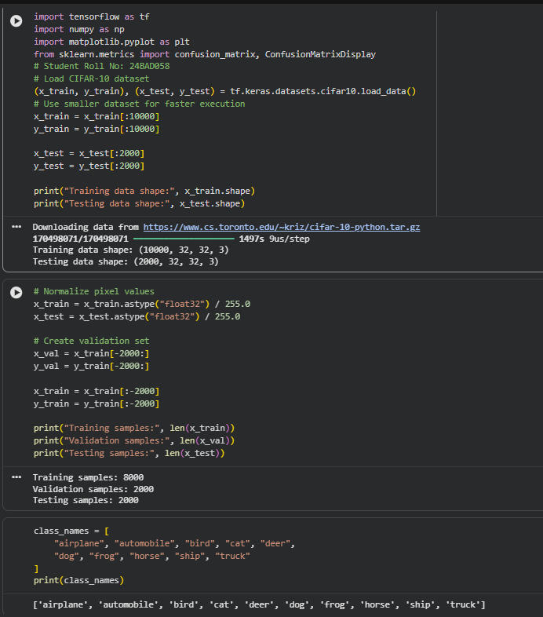

PART B: CNN MODEL IMPLEMENTATION
Build a CNN model consisting of:
- Convolution layers
- ReLU activation
- Max Pooling layers
- Fully Connected layers
- Softmax output layer

Compile the model using:
- Appropriate optimizer
- Cross-entropy loss function

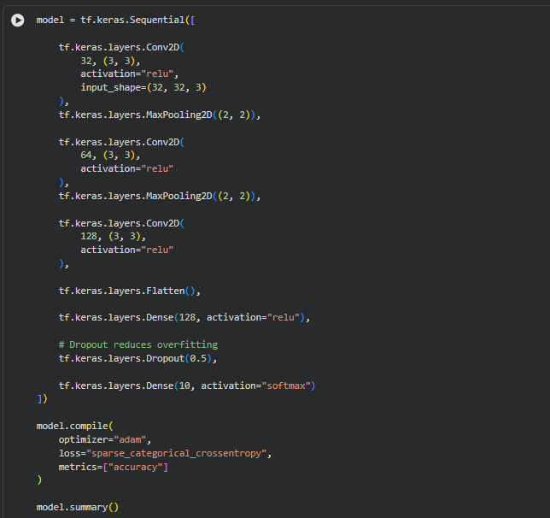

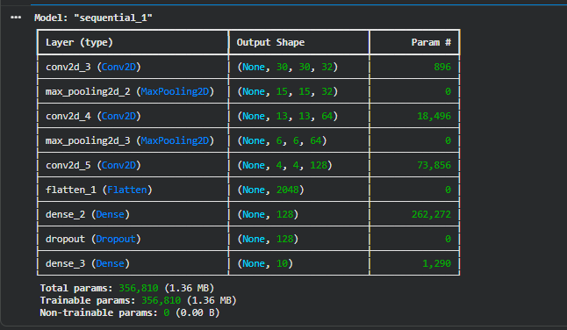

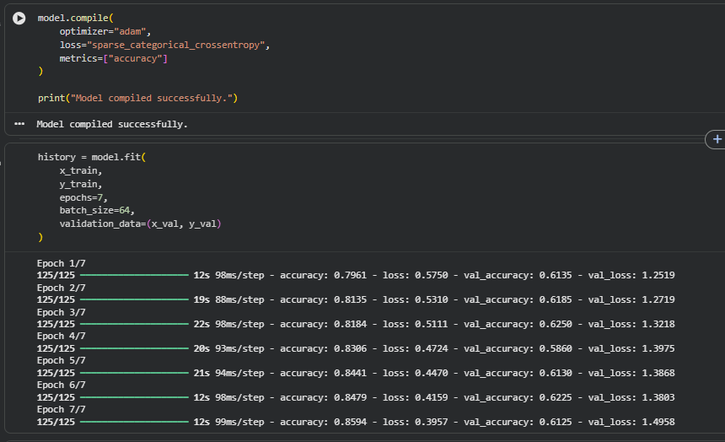

PART C: MODEL TRAINING AND EVALUATION
Train the CNN model.
Record:
- Training accuracy
- Validation accuracy
- Training loss
- Validation loss
- Testing accuracy
Plot:
- Accuracy vs Epoch
- Loss vs Epoch

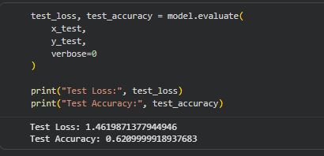

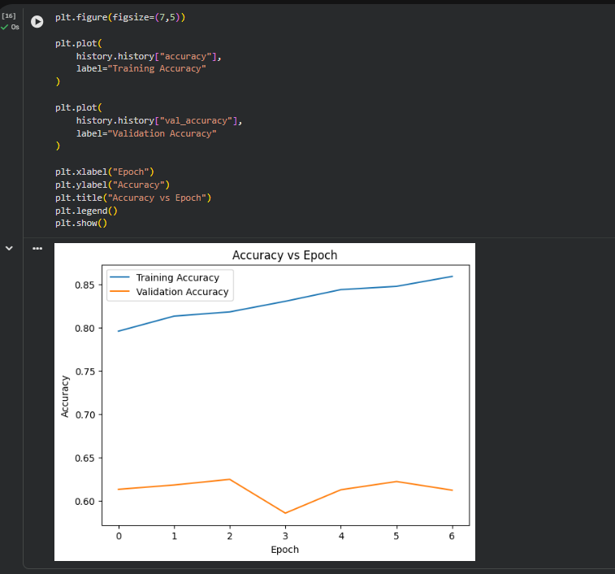

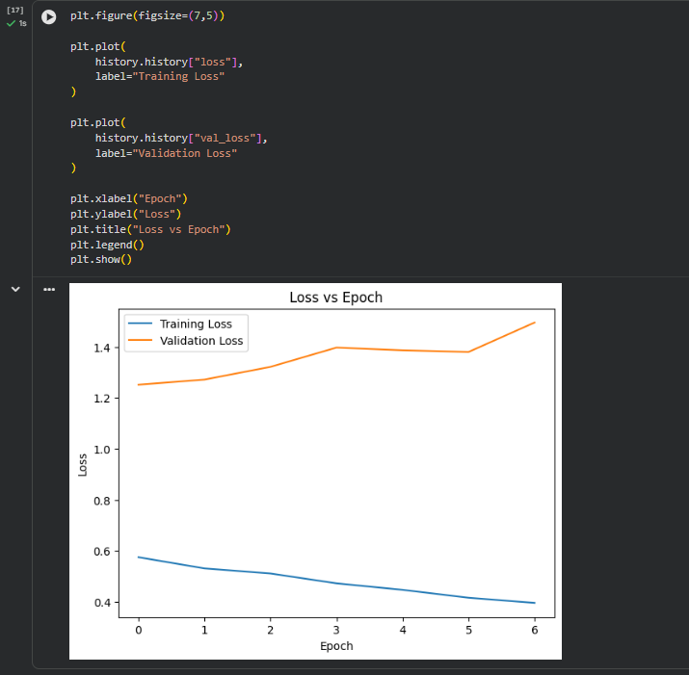

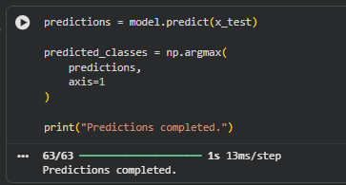

PART D: PERFORMANCE ANALYSIS
Analyze:
- Classification accuracy
- Confusion Matrix
- Sample predictions
- Misclassified images
Discuss the strengths and limitations of CNNs for image classification.

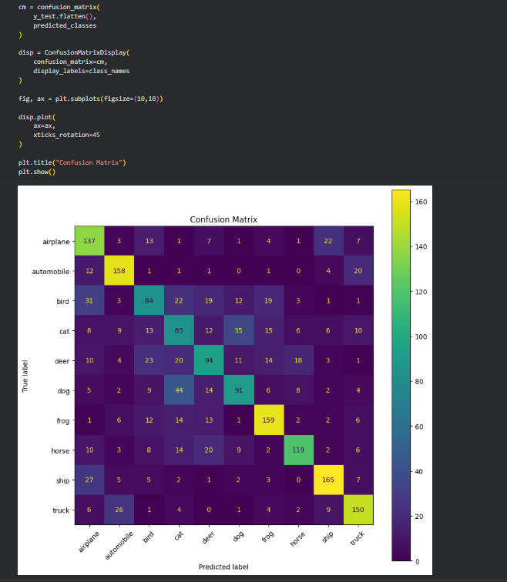

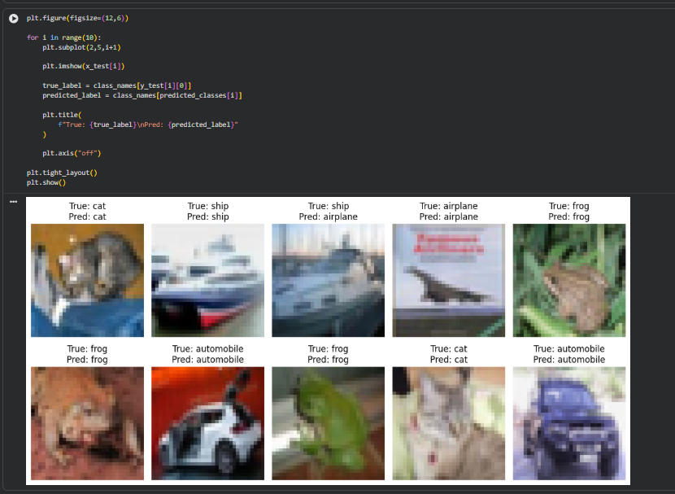

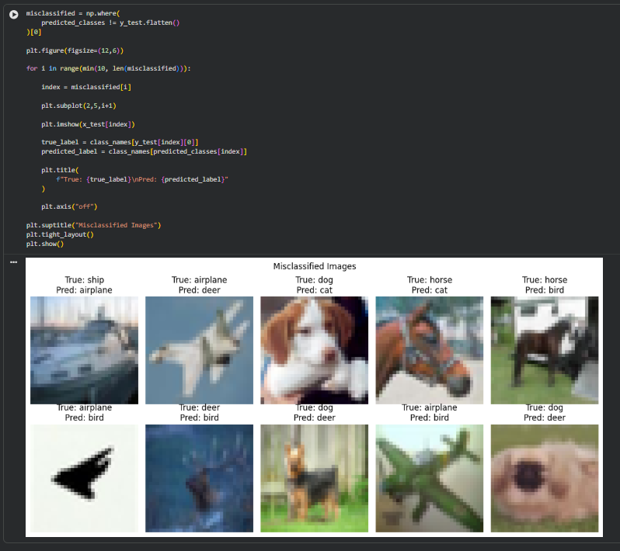

EXPECTED OUTCOME
Students will gain practical experience in designing, training, and evaluating CNN models for image classification and understand how CNN architecture influences classification performance.

POST-LAB QUESTIONS (PROVIDE BRIEF ANSWERS TO THE FOLLOWING QUESTIONS)
- Why are convolution layers more effective than fully connected layers for image processing?

Convolution layers are designed to detect spatial features such as edges, textures, and shapes. They use fewer parameters than fully connected layers by sharing weights. This makes CNNs faster, more efficient, and better at understanding image patterns.

- How does Max Pooling improve CNN performance?

Max Pooling reduces the size of feature maps while keeping the most important features. It decreases computation and the number of parameters, making the model faster. It also helps reduce overfitting and provides some tolerance to small changes in image position.

- Which hyperparameters significantly affected your CNN model performance?

Important hyperparameters include learning rate, batch size, number of epochs, number of convolutional filters, kernel size, and dropout rate. Among these, the learning rate and number of epochs can have a major effect on training speed and accuracy.

- What challenges did you encounter while training the CNN model?

Common challenges include overfitting, long training time, low validation accuracy, and selecting suitable hyperparameters. Limited computational resources and insufficient training data can also affect model performance.

- Suggest two improvements that can increase the classification accuracy of your CNN.

Use data augmentation such as rotation, flipping, and zooming to increase the variety of training images.
Use hyperparameter tuning and techniques such as dropout or batch normalization to improve the model's generalization and accuracy.

ASSESSMENT
Description | Max Marks | Marks Awarded
Pre Lab Exercise | 5
In Lab Exercise | 10
Post Lab Exercise | 5
Viva | 10
Total | 30
Faculty Signature

